
Complete project blueprint
VANA CARE
Offline AI Field Health & Survival Intelligence
Powered by Gemma 4 · Android · Edge AI · Offline-first
No Network. No Cloud. Still Not Alone.
VANA CARE is a privacy-first, offline-capable mobile application that combines AI-assisted first aid, symptom assessment, forest navigation, wilderness safety and emergency response in a single application.
1. Project overview
VANA CARE is designed for people who may need medical guidance or emergency assistance in places where internet connectivity is unreliable or completely unavailable.
Instead of relying on a cloud-based AI assistant, VANA CARE uses an on-device Gemma model, a locally stored medical knowledge base, offline maps and Android hardware sensors.
Local AI
Gemma-powered reasoning and multimodal assistance.
First aid
Guided emergency assessment and validated procedures.
Forest navigation
Offline maps, GPS, compass and route tracking.
Emergency response
SOS, emergency contacts and location sharing when supported.
Primary objectives
- Provide immediate access to essential first-aid information without an internet connection.
- Help users understand symptoms and recognize emergency warning signs.
- Provide visual and voice-based assistance through an on-device AI model.
- Help forest visitors navigate using downloaded maps and device sensors.
- Preserve essential trip and emergency information locally.
- Support regional languages, including Telugu and Hindi.
Product scope: VANA CARE is an emergency-information and decision-support tool, not a substitute for medical professionals or a guaranteed rescue service.
2. Target users
User group | Main use case
Trekkers and hikers | Injuries, navigation and getting lost
Forest visitors | First aid, wildlife safety and offline guidance
Campers | Emergency preparedness and survival information
Rural communities | Offline access to basic health guidance
Field workers | Remote-area safety and emergency procedures
Disaster volunteers | Initial incident assessment and communication
Students and explorers | Outdoor safety and emergency preparedness
Community health workers | Access to locally stored health reference material
The application should be useful even for someone with limited technical knowledge. Large controls, simple language, voice interaction and a clearly visible emergency button are essential.
3. Core product modules
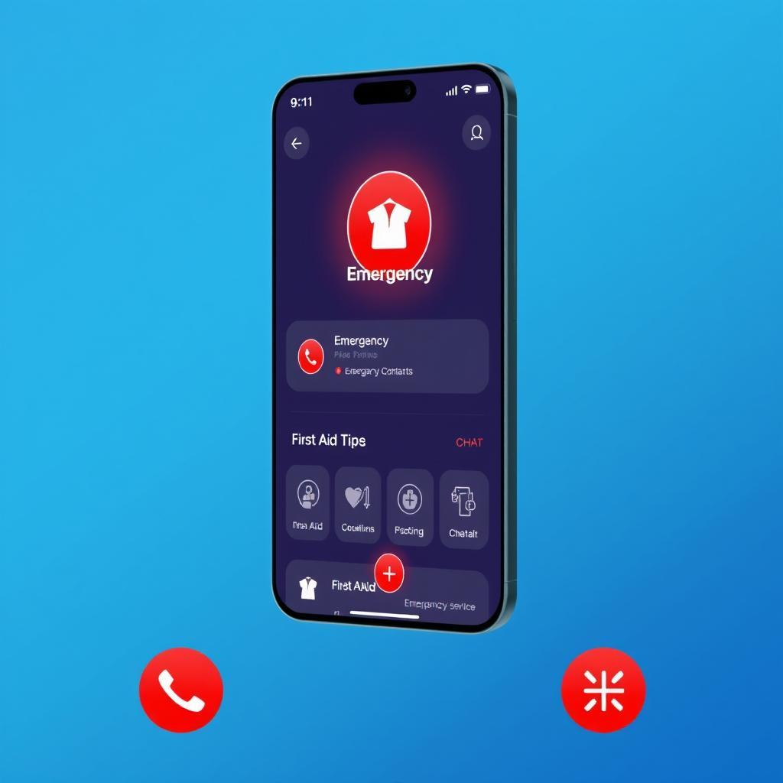
1. Emergency Mode
Critical module
A dedicated emergency interface with large controls for bleeding, injuries, burns, breathing difficulties, unconsciousness, bites and other emergencies.
- One-tap access to emergency instructions.
- Structured emergency assessment.
- Call 112 and access saved emergency contacts.
- Display the current GPS position when available.
- Create an emergency report for sharing.
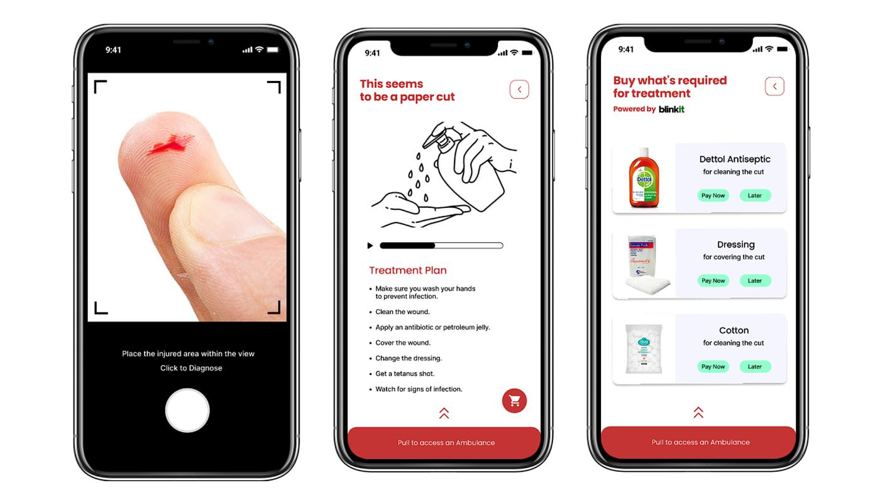
2. AI First-Aid Vision Assistant
Multimodal AI
Uses the camera to inspect an injury image and identify visible features that may be relevant to a first-aid workflow.
- Camera and gallery input.
- Local image processing with a compatible Gemma vision model.
- Visible-feature summaries.
- Relevant, source-backed first-aid guidance.
- Warnings when the image is unclear or professional assessment is needed.
It must never claim to diagnose an injury from an image.
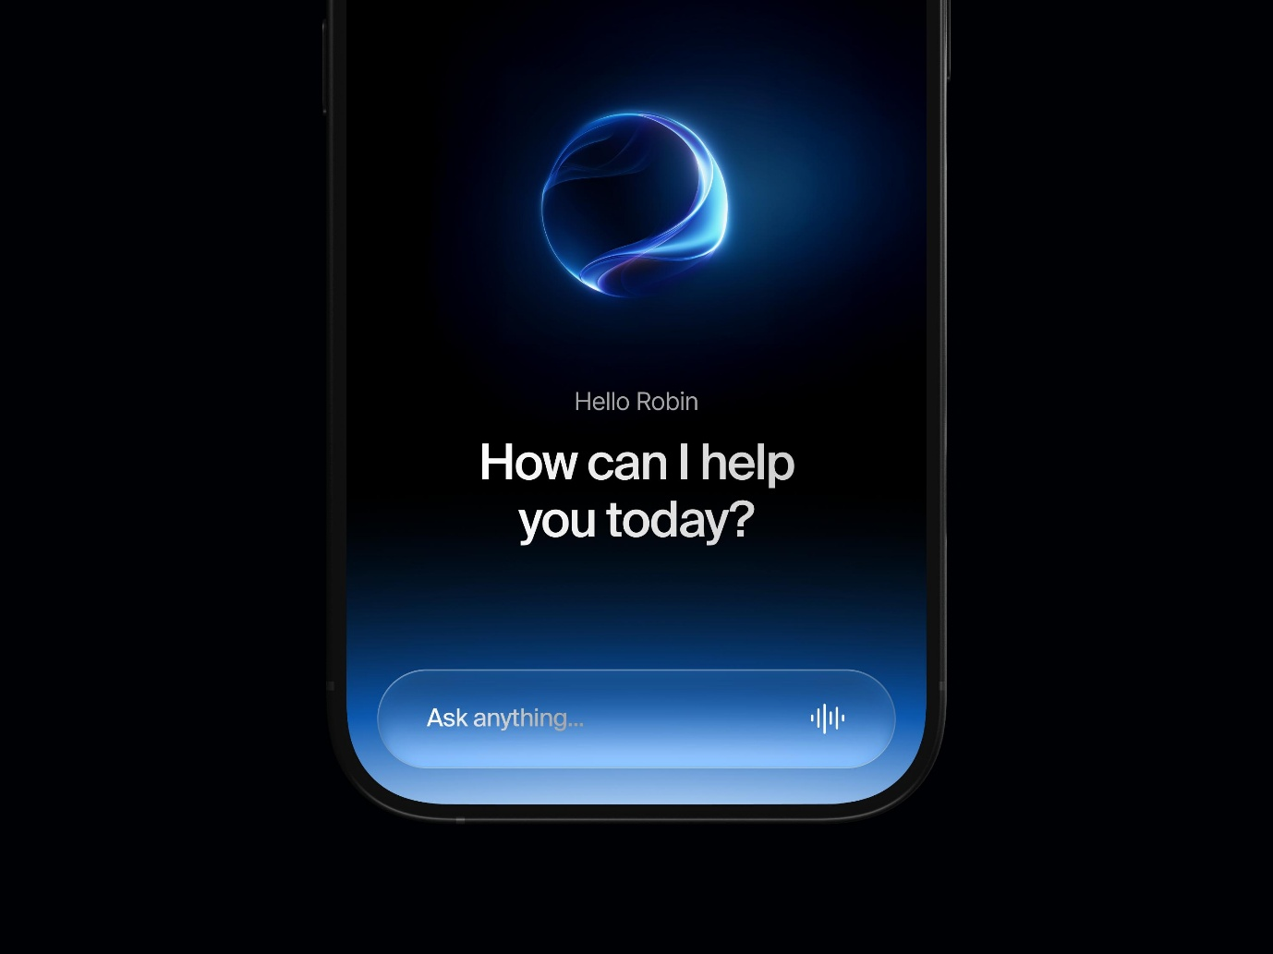
3. Offline Health Assistant
Local Gemma
A voice- and text-based assistant that helps users describe symptoms and understand approved health information.
- Symptom collection and clarification.
- Structured assessment using approved decision pathways.
- Voice interaction and multilingual responses.
- Locally retrieved health information.
- Escalation when emergency warning signs are reported.
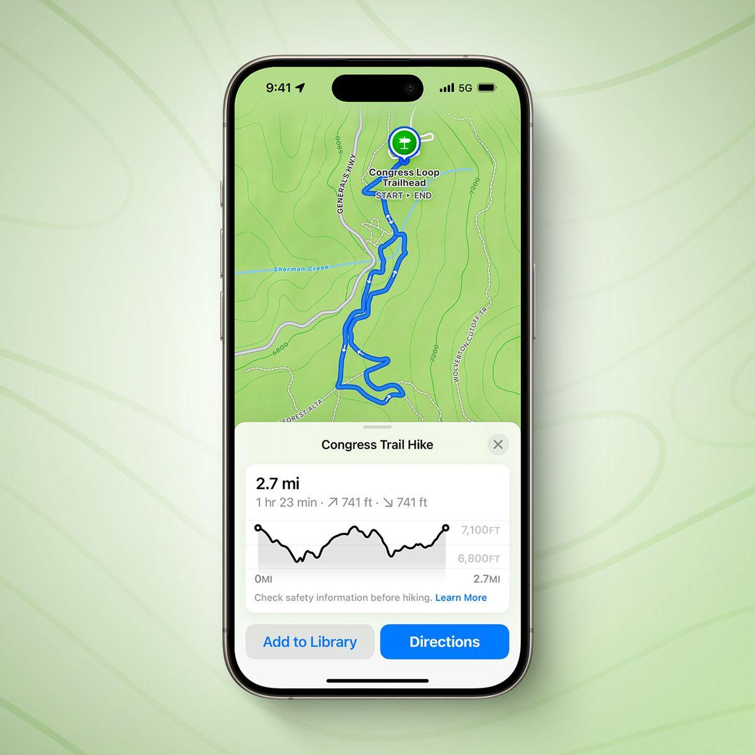
4. Forest Mode
Offline navigation
A dedicated mode for people entering forests, remote trails and other areas with unreliable network coverage.
- Downloadable regional maps.
- GPS positioning and digital compass.
- Recorded trail and route breadcrumbs.
- Saved starting location and return-to-start assistance.
- Local forest safety information.
- Battery-conscious operation.
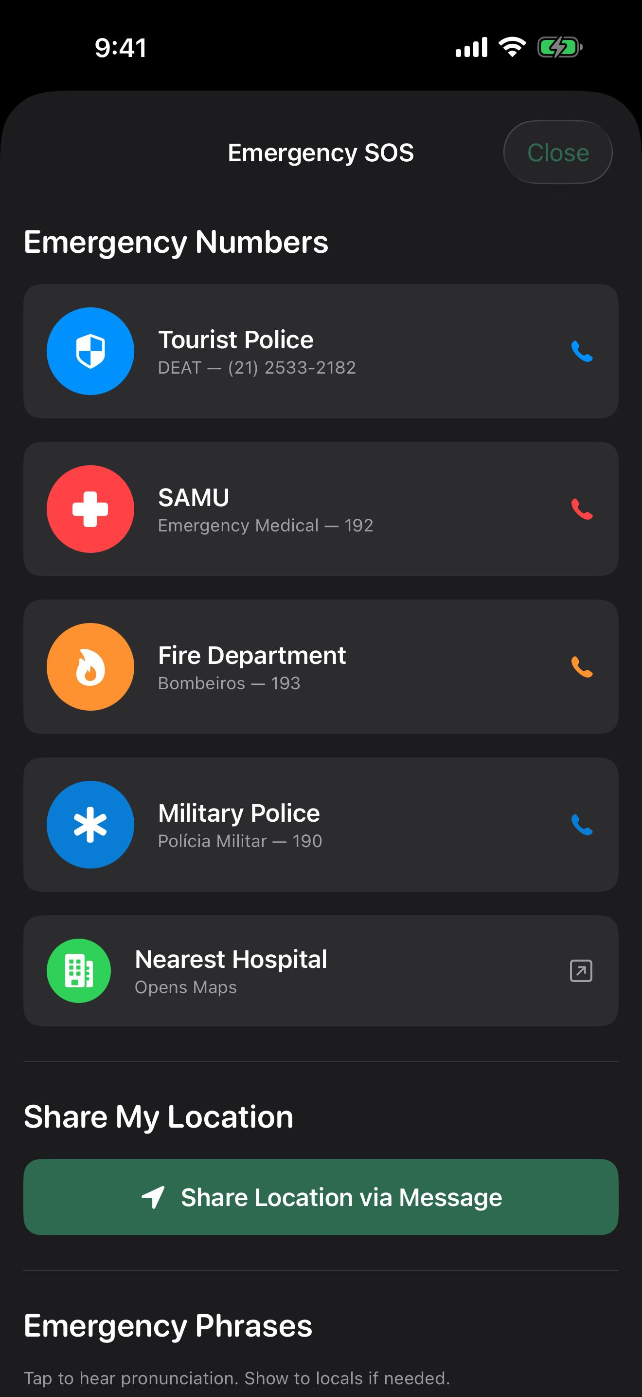
5. SOS and Emergency Communication
Safety critical
Helps users prepare and transmit emergency information when a suitable communication channel is available.
- Call India's 112 emergency number.
- Prepare emergency SMS where supported.
- Share GPS coordinates.
- Store emergency contacts.
- Create a compact emergency packet.
- Preserve the last known location.
GPS can work without mobile data, but SOS communication generally requires a supported communication connection.
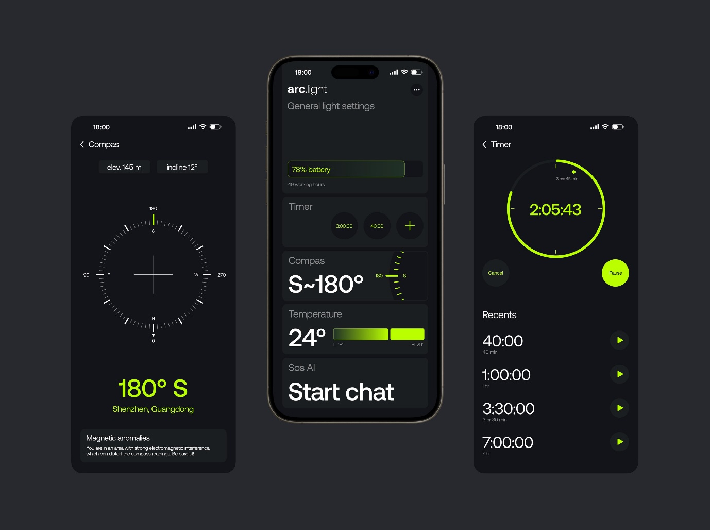
6. Survival Toolkit
Essential utilities for remote environments.
- Compass and flashlight.
- Altitude, where device hardware supports it.
- Offline emergency guides.
- Survival checklists.
- Water and shelter guidance.
- Battery-saving mode.
4. Complete application screen structure
The app should use a premium iOS-inspired liquid-glass visual language, while retaining Android-native navigation, accessibility and predictable emergency interactions.
Main navigation
Home
Explore
AI
Library
Profile
Emergency access should remain prominently available from the home screen and critical workflows, not hidden in a navigation menu.
A. Onboarding and setup

1. Splash screen
Brand identity and offline-first positioning.
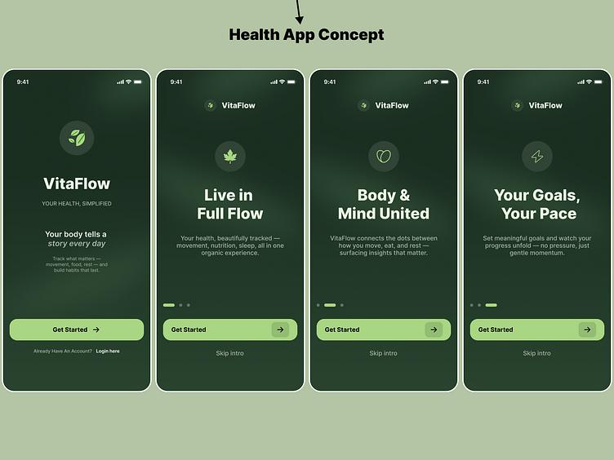
2. Onboarding
Explain AI, offline availability and safety limitations.
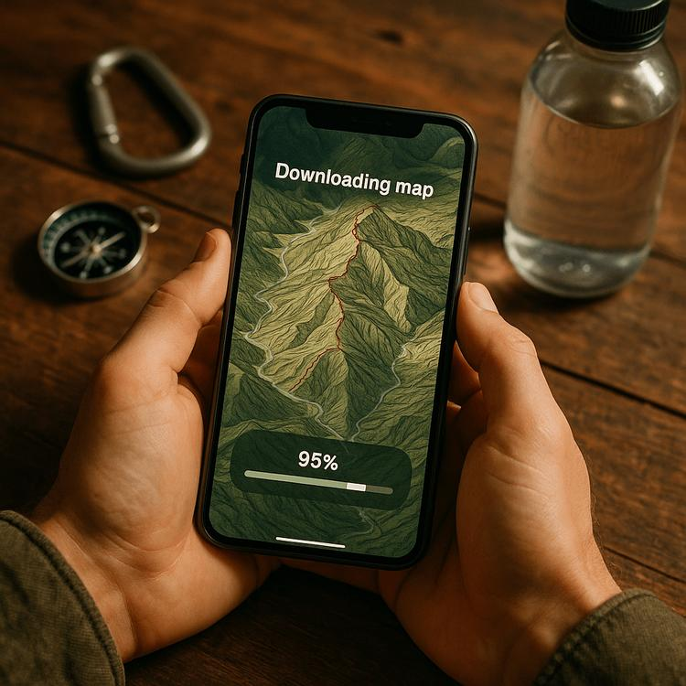
3. Offline setup
Choose language, maps and knowledge packs.
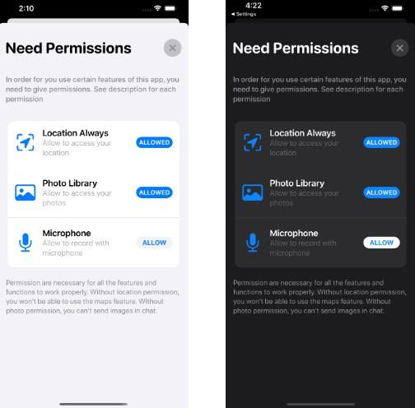
4. Permissions
Explain and request location, camera and microphone access when needed.
B. Main application
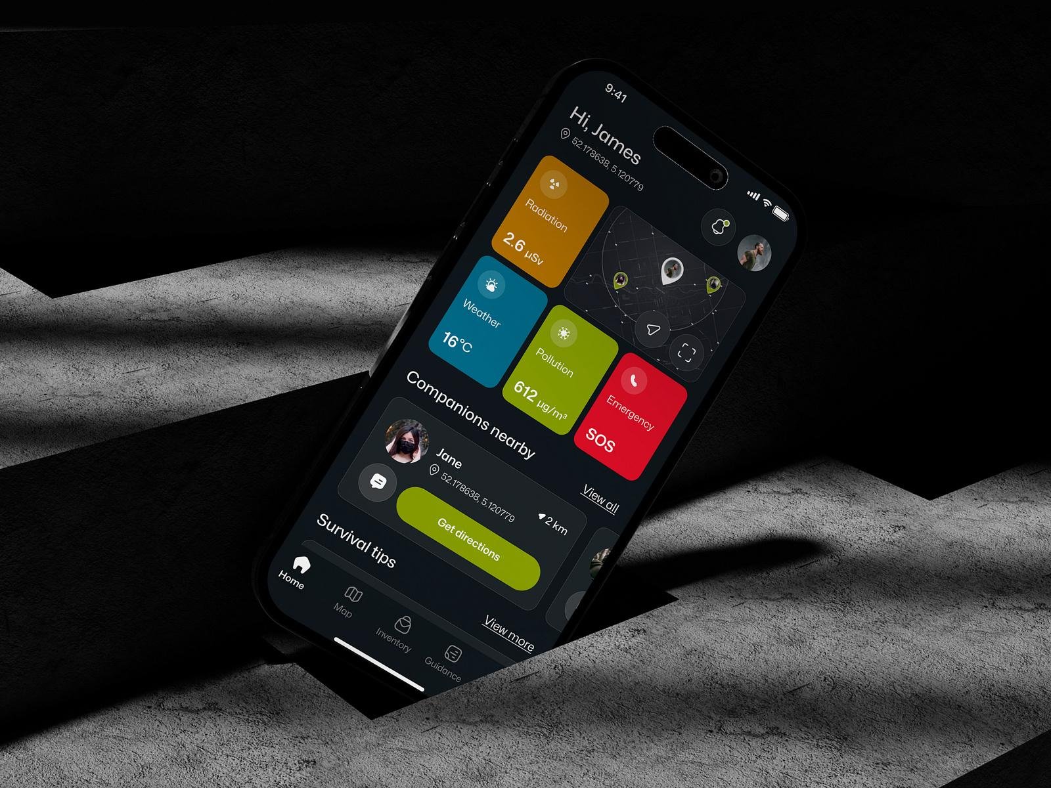
5. Home dashboard
Offline status, emergency access, first aid, AI and Forest Mode.
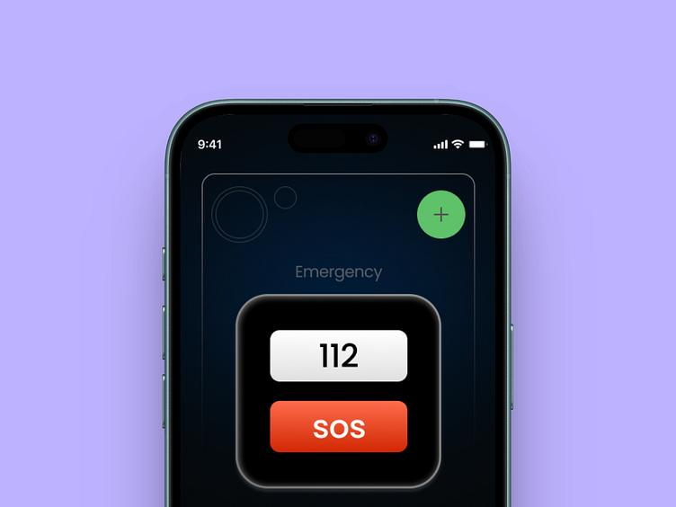
6. Emergency Mode
Emergency category selection and direct access to help.
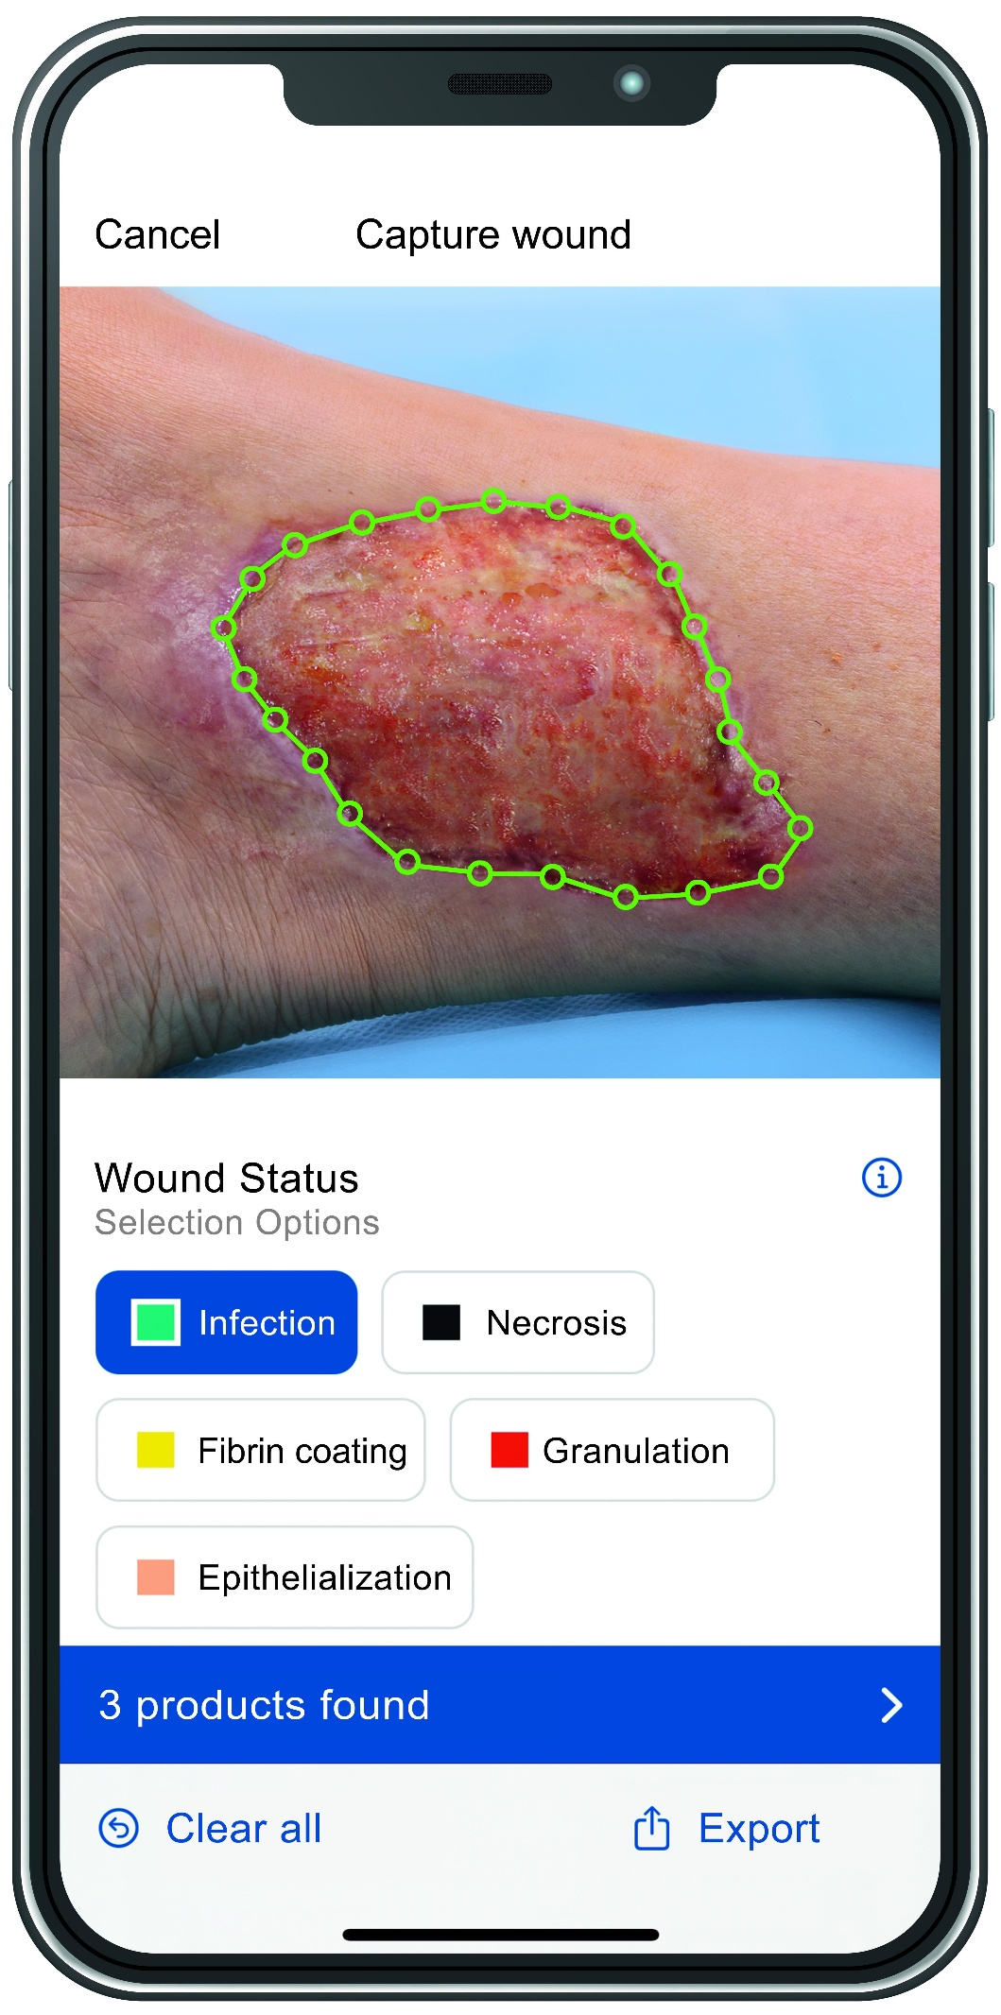
7. Vision assistant
Capture or select an image for visual assessment.
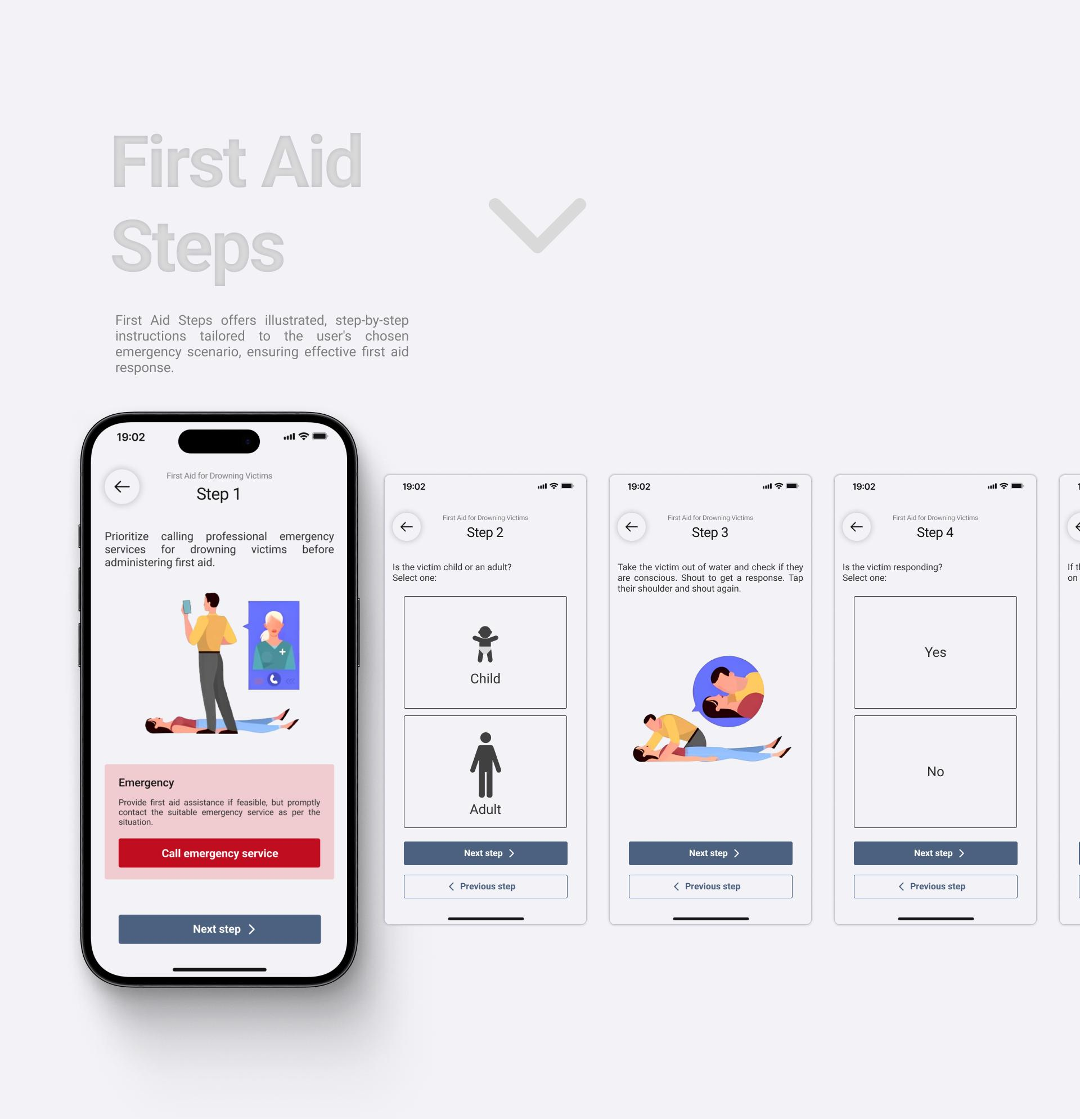
8. First-aid instructions
Validated, step-by-step guidance with warning signs.
9. Voice health assistant
Speak or type symptoms in a supported language.
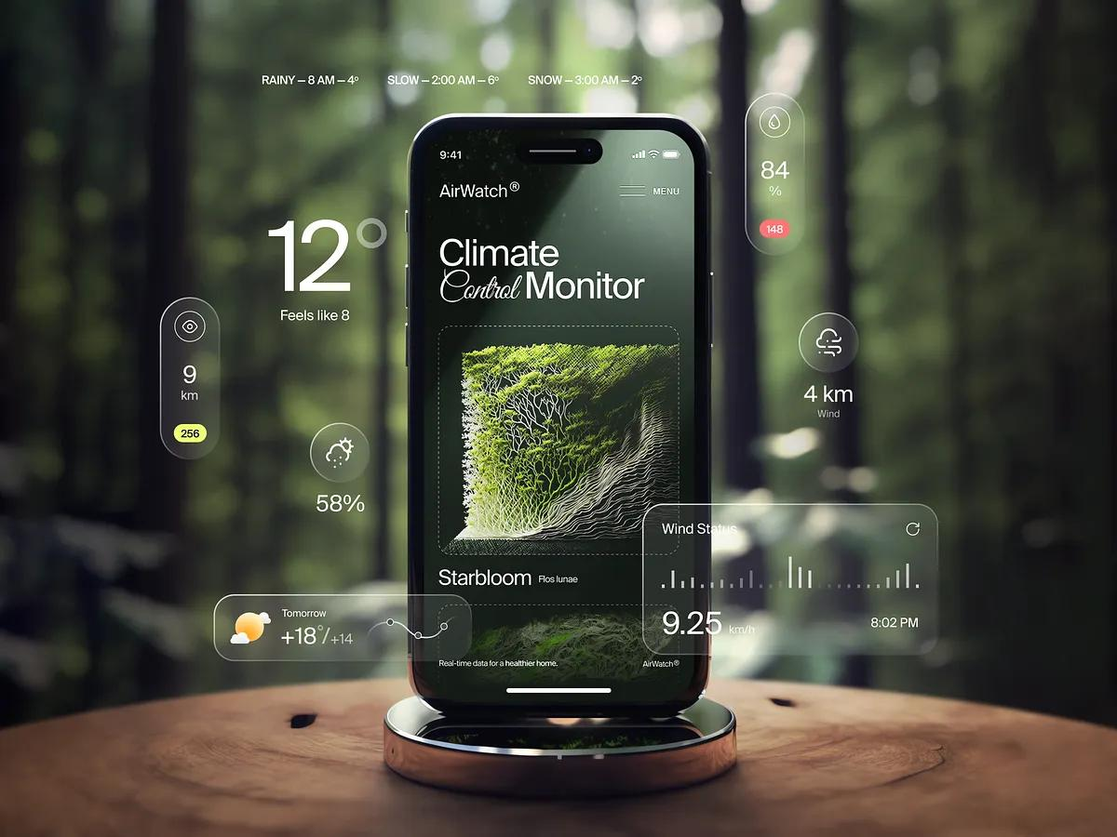
10. Forest dashboard
Downloaded area, GPS, trip and safety information.
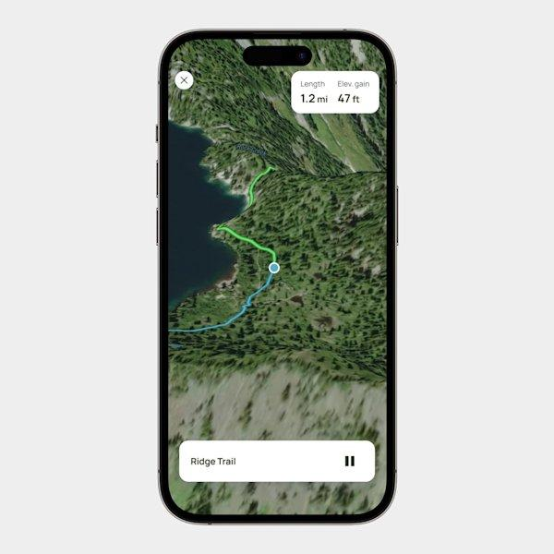
11. Offline navigation
Map, route recording, compass and saved location.
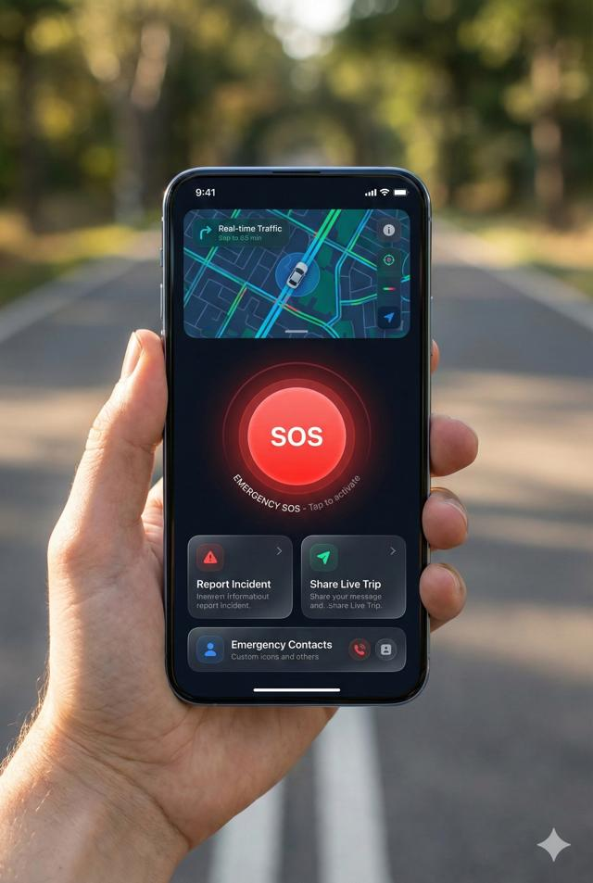
12. Lost Mode
Last known position, recorded trail and emergency actions.
13. Survival toolkit
Compass, flashlight, checklists and safety references.
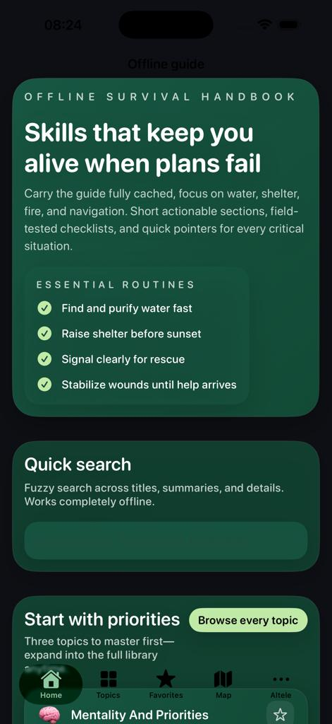
14. Knowledge library
Searchable local first-aid, health and wilderness guides.
5. Detailed user journeys
The screens are only one part of the product. These are the workflows that make VANA CARE useful.
Workflow 1
A person gets injured in a forest
- Open Emergency Mode
The user chooses the type of emergency or starts voice input.
- Assess the situation
The application follows the relevant, medically reviewed assessment pathway and identifies urgent warning signs.
- Use the camera, if appropriate
The user can provide a photograph. Gemma describes visible features and indicates uncertainty.
- Show first-aid instructions
The application retrieves an approved procedure and presents it in simple language, with audio support where available.
- Request help
The user can call 112, contact a saved person or prepare an emergency report.
Workflow 2
Someone gets lost during a trek
- Open Forest Mode and select I'm Lost.
- Read the current GPS position and accuracy, if available.
- View the downloaded map and previously recorded route.
- Use the compass and the app's saved trip information to understand the situation.
- Open the lost-person checklist and contact emergency services when necessary.
The app should not promise a safe return route when the map, GPS fix or terrain information is insufficient.
Workflow 3
A rural user needs health guidance
- Select a language and open the health assistant.
- Describe the symptoms by voice or text.
- Answer a small number of relevant questions.
- Receive locally available, source-backed health information and appropriate escalation advice.
- Save a summary for a healthcare professional if needed.
6. Medical knowledge and safety design
This is the most important part of VANA CARE. Medical instructions need a more controlled architecture than an ordinary conversational application.
WHO's Basic Emergency Care course uses a systematic approach to the initial assessment and management of time-sensitive conditions. Its community first-aid material also emphasizes recognizing life-threatening conditions, providing initial care and arranging transfer to higher-level care. These are suitable foundations for developing the application's content with qualified medical reviewers.

World Health Organization
+1
Medical knowledge categories
Category | Included content
First aid | Bleeding, wounds, burns, injuries
Breathing | Recognition of breathing emergencies
Consciousness | Unconsciousness and altered mental status
Environmental | Heat illness, cold exposure and dehydration-related concerns
Bites and stings | Emergency recognition and appropriate escalation
General health | Symptom information and warning signs
Preparedness | First-aid kit, emergency checklists and prevention
Each procedure must be reviewed, versioned and linked to its authoritative source before release.
Three-layer medical safety system
Layer 1 — Medical protocols
Clinician-reviewed instructions, contraindications and escalation criteria.
Layer 2 — Safety engine
Deterministic rules, validated responses and emergency routing.
Layer 3 — Gemma
Language understanding, image summaries, retrieval and clear explanations.
The AI must never override an emergency rule or invent a treatment when the relevant information is absent. If it is uncertain, it should state that uncertainty and show the appropriate escalation instructions.
7. AI architecture using Gemma 4

Gemma 4 E4B
Proposed primary model
On-device model, subject to device benchmarking
Gemma 4 includes compact E2B and E4B models designed for efficient deployment. E4B supports text, image and audio inputs, making it a useful candidate for VANA CARE's multimodal requirements. The E2B model is a fallback to evaluate for less powerful phones.

Google AI for Developers
+1
Capability | Model responsibility
Text | Understand questions and explain guidance
Vision | Summarize visible image features
Audio | Process supported speech input
Reasoning | Interpret user-provided context
Function calling | Request permitted app functions
Multilingual | Process and respond in supported languages
RAG | Use retrieved, locally stored knowledge as context
Recommended AI pipeline
User input
Text · Image · Voice · Sensor data
Input preprocessing
Image resizing, speech recognition and data validation
Gemma 4 E4B
Local multimodal inference
Local RAG
Retrieve approved knowledge
Safety engine
Validate actions and responses
Structured response
Instructions, warnings, source and permitted actions
AI model responsibilities
I recommend keeping separate prompts and output schemas for each task rather than using one enormous system prompt.
AI task | Output
Image assessment | Visible features, image quality and uncertainty
Symptom collection | Structured symptoms and relevant missing information
Health explanation | Plain-language explanation grounded in local sources
Forest assistant | Answers from the downloaded regional guide
Voice interaction | Conversational response in the selected language
Trip assistant | Summarized trip information and checklists
For safety-critical workflows, the model should request an application function rather than directly executing an action. For example, it can request a location lookup, but Android should retrieve and validate the location.
Important: benchmark E4B on the actual target phones. Model size, quantization, available RAM, thermal performance and inference latency will determine whether image and voice processing can run together comfortably.
8. Offline-first system architecture
VANA CARE should work without requiring an account, backend or network connection for its core features.
Proposed system architecture
Android application
Kotlin · Jetpack Compose
AI engine
Gemma + LiteRT
Medical engine
Protocols + validation
Navigation
GPS + offline maps
Storage
Room + local files
Local device storage
Medical packs · Model files · Trips · Emergency records · Maps
Optional online services
Download updates, synchronize authorized records and obtain online information when connected.
Recommended technology stack
Layer | Technology | Purpose
Mobile | Kotlin | Core Android development
UI | Jetpack Compose | Premium, responsive interface
Design | Material 3 + custom glass components | Android-native design with liquid-glass styling
AI | Gemma 4 E4B / E2B | Local multimodal inference
Inference | Google AI Edge / LiteRT | On-device model execution
Camera | CameraX | Image capture
Database | Room / SQLite | Offline records
Vector search | SQLite-based vector indexing | Local semantic retrieval
GPS | Android Location APIs | Current position
Compass | Android sensor APIs | Direction
Maps | Mapbox offline or an OpenStreetMap-based solution | Downloadable regional maps
Speech | Compatible offline ASR and Android TTS | Voice input and speech output
Background tasks | WorkManager | Deferred updates and synchronization
Optional backend | Supabase | Authorized synchronization and shared services
Google's Gemma documentation provides the model information needed to evaluate E2B and E4B for mobile inference. The actual runtime and supported model format should be verified before committing to a specific Android inference implementation.
Google AI for Developers
+1
Suggested Android project structure
com.vanacare
│
├── app
│ ├── navigation
│ ├── theme
│ └── MainActivity.kt
│
├── core
│ ├── database
│ ├── ai
│ ├── location
│ ├── permissions
│ ├── offline
│ └── security
│
├── feature
│ ├── home
│ ├── emergency
│ ├── firstaid
│ ├── vision
│ ├── health
│ ├── forest
│ ├── navigation
│ ├── lostmode
│ ├── survival
│ ├── knowledge
│ ├── trips
│ └── profile
│
├── domain
│ ├── models
│ ├── usecases
│ └── safety
│
└── data
├── repository
├── protocols
├── maps
└── sync
This modular structure will let you improve the AI, maps or medical content independently without rewriting the entire application.
9. Database design
The database should be local-first, with sensitive information stored on the device by default.
Table | Important fields | Purpose
UserProfile | id, name, language, preferences | Local user settings
EmergencyContact | id, name, phone, relationship | Saved emergency contacts
MedicalProtocol | id, category, version, source, content | Reviewed emergency procedures
KnowledgeChunk | id, document_id, text, embedding | Local RAG retrieval
HealthSession | id, created_at, summary, status | User-initiated health sessions
SymptomEntry | session_id, symptom, duration, severity | Structured symptom records
ImageAssessment | id, session_id, description, consent | Optional image-assessment history
Trip | id, name, start_time, planned_return | Trip information
RoutePoint | trip_id, latitude, longitude, timestamp | Recorded trail
OfflineRegion | id, region_name, version, size | Downloaded region metadata
EmergencyEvent | id, event_type, coordinates, timestamp | Emergency reports
SyncQueue | id, record_id, status, retry_count | Deferred synchronization
Privacy design
- Medical information and image assessments should remain on the device by default.
- Give users explicit control over saving or deleting health sessions.
- Do not collect continuous location when it is not needed.
- Encrypt sensitive records and avoid exposing personal details in logs.
- Make any optional cloud synchronization transparent and consent-based.
10. Premium UI and color system
Your liquid-glass mockup can be developed into a consistent design system rather than a collection of unrelated screens.
Recommended VANA CARE palette
Forest
#0F2D23
Sage
#3E6B5A
Mist
#F4F2EC
Sky
#3882F6
Orange
#F97316
Alert
#EF4444
Deep Navy
#081220
Glass
#F8FAFF
Design element | Recommended treatment
Main background | Mist in light mode, Deep Navy in dark mode
Primary actions | Forest Green
AI assistant | Sky Blue and subtle violet gradients
Emergency actions | Alert Red
Warnings | Warm Orange
Cards | Translucent, blurred surfaces with restrained borders
Typography | Large, highly legible system typography
Navigation | Floating translucent bottom bar
Icons | Rounded, consistent line icons
Use liquid glass selectively: navigation bars, AI controls, floating actions and non-critical cards. Medical instructions and emergency buttons should remain high-contrast, solid and legible, even in bright sunlight.
Accessibility requirements
- Support dynamic font scaling and screen readers.
- Maintain strong contrast in both themes.
- Never communicate danger through color alone.
- Use large touch targets and simple wording.
- Provide text alongside voice guidance.
- Keep emergency actions available without complex gestures.
11. Offline functionality matrix
Not everything can work offline. This distinction should be clear to users.
Feature | Offline availability | Limitation
Local Gemma text AI | Yes | Compatible model must be installed
Image assessment | Yes | Requires compatible model and sufficient hardware
Voice assistance | Yes | Offline speech components must be installed
Medical library | Yes | Content must be downloaded
First-aid workflows | Yes | Locally stored protocols
GPS | Usually | Requires adequate satellite reception
Compass | Usually | Requires suitable device sensor
Offline maps | Yes | The relevant region must be downloaded
Live weather | No | Only a previously downloaded snapshot is available
SOS call | Conditional | Requires an available supported connection
Emergency SMS | Conditional | Requires a functioning supported messaging channel
Live location sharing | No | Requires a working communication channel
Cloud synchronization | No | Requires internet
Android documentation warns that frequent, high-accuracy location requests can consume substantial battery power. Background location also has system restrictions, so VANA CARE should use foreground tracking during active trips and request only the location permissions it genuinely needs.

Android Developers
+1
12. Forest Mode in greater detail
Forest Mode deserves to be a separate experience rather than just another page in the app.
Before entering the forest
Download a regional safety pack
- Offline map for the intended area
- Medical and first-aid knowledge pack
- Forest and trail safety guide
- Emergency contact information
- Supported language and speech packs
- Latest available weather forecast snapshot
During the trip
Trail recording
Save route points and the starting location.
Orientation
Show direction and GPS accuracy.
Survival battery
Reduce unnecessary AI and GPS processing.
Local survival guides
Access downloaded guides without a connection.
The application should distinguish the user's recorded path from a verified trail. A return-to-start function can display the recorded path, but it cannot guarantee safe passage through terrain or changing environmental conditions.
13. Emergency communication design
India's Emergency Response Support System uses 112 as the integrated emergency number and supports multiple ways to request assistance. The official 112 India app can also send location information with an emergency request.
Emergency Services
VANA CARE should complement this existing infrastructure.
Important distinction
Offline emergency packet
When there is no connection, the application can prepare and store a report locally. It must not claim that the report has reached a rescuer.
When communication becomes available, the user can share the report through a supported channel.
Suggested emergency packet fields:
VANA CARE — EMERGENCY REPORT

Incident ID
Incident category
Timestamp
Current GPS coordinates
GPS accuracy
Last known position
Battery level
User-entered description
Relevant symptom summary
Emergency contact
Optional image attachments
Communication status
Only collect and share sensitive details with the user's authorization, except where a clearly disclosed, legally justified emergency workflow applies.
14. Performance and device requirements
You should design for mid-range Android devices, not just flagship phones.
Requirement | Proposed target
Operating system | Android 12 or later as an initial target
Primary language | Kotlin
UI framework | Jetpack Compose
AI model | Gemma 4 E4B, with E2B fallback
Storage | At least 2 GB free recommended for the full offline pack; refine after measuring actual assets
Internet | Needed for initial model, map and knowledge downloads
GPS | Device with location hardware
Compass | Optional; use a fallback if unavailable
Camera | Optional for image assessment
Microphone | Optional for voice interaction
Performance benchmarks to establish during development
- App launch and offline home-screen loading time.
- AI response latency for short text questions.
- Image-analysis latency on representative devices.
- Peak memory usage and thermal throttling.
- Battery consumption during a typical trek.
- Offline map rendering and location-update performance.
- Recovery after the app is terminated or the device restarts.
Do not promise a universal response time until you have measured it on the devices you intend to support.
15. Security, privacy and regulatory considerations
VANA CARE handles sensitive health and location information. Privacy and safety need to be part of the product architecture from the beginning.
Privacy
- Process health questions and images locally by default.
- Obtain consent before saving sensitive records.
- Make location tracking visible and user-controlled.
- Offer a clear deletion option.
- Use encrypted local storage for sensitive information.
- Keep diagnostic logs free of personal medical information.
Medical safety
- Obtain medical review of all emergency procedures.
- Version the medical content and preserve its source.
- Validate each emergency pathway with clinicians and first-aid experts.
- Test performance on difficult images, mixed-language speech and incomplete symptom descriptions.
- Clearly communicate the limitations of AI-generated content.
Indian regulatory considerations
India's CDSCO regulates medical devices, including certain software intended for diagnosis, monitoring or treatment. Its medical-device guidance should be reviewed when defining VANA CARE's intended purpose. Whether particular features qualify as regulated medical-device software depends on their actual functionality and claims; a qualified regulatory professional should assess the intended product before public release.

CDSCO
16. Development roadmap
I recommend building VANA CARE in stages so you can test the critical offline functions before investing in more advanced AI features.
Proposed 12-week roadmap
An indicative schedule for a focused prototype; actual duration depends on model integration and available development resources.
- Weeks 1–2: Foundation and UI
  - Define the PRD and screen flows.
  - Set up Kotlin and Jetpack Compose.
  - Build the navigation, themes and onboarding.
  - Create Room entities and offline storage.
- Weeks 3–4: Offline AI
  - Integrate a compatible Gemma runtime.
  - Benchmark E2B and E4B.
  - Build the local conversation interface.
  - Implement local document retrieval and source display.
- Weeks 5–6: First aid and vision
  - Develop the medically reviewed emergency workflows.
  - Integrate CameraX.
  - Add image assessment and uncertainty handling.
  - Implement symptom collection and escalation.
- Weeks 7–8: Forest Mode
  - Implement GPS and compass.
  - Integrate downloadable offline maps.
  - Add trip creation, route recording and Lost Mode.
  - Develop battery-conscious tracking.
- Weeks 9–10: Emergency and voice
  - Add emergency contacts and 112 access.
  - Build emergency packets.
  - Integrate offline voice input and speech output.
  - Add Telugu and Hindi content.
- Weeks 11–12: Testing and release preparation
  - Test in airplane mode.
  - Run medical safety reviews.
  - Test on low- and mid-range devices.
  - Improve accessibility and battery performance.
  - Prepare a controlled prototype release.
17. Testing and evaluation
For this project, functional testing alone is insufficient. You need separate evaluation tracks for AI, medical safety, navigation, offline reliability and privacy.
Test area | What to verify
Offline reliability | Every advertised offline feature works after network disconnection
Medical safety | Approved procedures appear in the right scenarios
AI reliability | The model does not invent unsupported medical instructions
Vision | Unclear or misleading images produce appropriate uncertainty
Voice | Supported languages work with realistic accents and noise
Navigation | GPS accuracy, route recording and offline maps work as intended
Battery | Tracking and AI do not cause excessive battery drain
Privacy | Sensitive data is not sent to the network without consent
Accessibility | Important tasks work with large text and assistive technology
Recovery | Trips and emergency records survive app restarts
For medical testing, use clinician-reviewed test scenarios, including cases where the safest response is to seek immediate professional help. Do not validate the system by measuring only how often it agrees with an expected AI-generated answer.
18. MVP versus future features
MVP · First release
VANA CARE 1.0
Use this checklist to track implementation progress.
Onboarding and offline setup
Local Gemma text assistant
Offline medical knowledge library
Reviewed first-aid workflows
Basic image assessment
Symptom collection
GPS and compass
Downloaded offline maps
Lost Mode and route recording
Emergency call and contact access
English and Telugu interface
Implementation checklist
0/11
Version 2
Advanced field intelligence
- Trip sharing and check-ins
- Emergency packet synchronization
- Additional Indian languages
- Expanded regional safety packs
- More sophisticated local RAG
- Improved battery optimization
Version 3
Connected field ecosystem
- Optional wearable integration
- Additional environmental sensors
- More advanced incident reporting
- Authorized community responder workflows
- Additional regional and organizational deployments
19. What makes VANA CARE distinct?
There are already offline health assistants and community-health applications. The distinction should not be that VANA CARE merely runs an LLM locally.
The defining product combination
Medical guidance
Vision AI
Offline AI
Forest navigation
Emergency communication
Survival utilities
The innovation is the integration of these functions into a coherent, offline-first experience, with clear boundaries between AI assistance and safety-critical functions.
The strongest demonstration would be a phone in airplane mode, running the local model, retrieving first-aid information, displaying a downloaded map and recording a trail. You can then demonstrate the emergency workflow separately, showing exactly which functions require a communication connection.
20. Distribution and future business model
You can initially release VANA CARE as a free Android prototype, with a focus on testing and gathering feedback.
Potential future deployment models include:
Model | Potential users
Free personal edition | Hikers, students and campers
Regional safety packs | Trekkers and forest visitors
Organizational deployment | NGOs and outdoor training organizations
Community-health edition | Rural health programs
Institutional edition | Training organizations and emergency-preparedness teams
For a health-related application, avoid monetization that encourages unnecessary collection of medical information. Paid regional content, organizational licensing or optional training features are more consistent with the privacy-first product design than targeted health advertising.
21. Final project specification

VANA CARE
Offline AI Field Health & Survival Intelligence
Android · Offline-first · Multimodal
Specification | Decision
Product type | Offline-capable Android application
Primary users | Forest visitors, rural users and field workers
Core AI | Gemma 4 E4B, benchmarked against E2B
UI framework | Kotlin + Jetpack Compose
Design | Premium iOS-inspired liquid glass
Core storage | Room and local files
AI knowledge | Local RAG with approved sources
Medical engine | Clinician-reviewed deterministic protocols
Navigation | GPS, compass and offline maps
Emergency | 112 integration and emergency contacts
Primary languages | English and Telugu; Hindi planned
Internet dependency | None for core downloaded offline features
Initial release | Android prototype
My recommendation
Build the first release around three experiences: Emergency Mode, AI First Aid and Forest Mode. Everything else should support those experiences.
First make the application genuinely useful with no network. Then add richer AI, more languages and connected features. That sequence will give you a coherent product instead of a large collection of partially working features.
Primary technical and medical references
- Google — Gemma 4 model card
: Model sizes, modalities, reasoning and deployment characteristics.
Google AI for Developers
- WHO — Basic Emergency Care
: A foundation for structured emergency assessment.
World Health Organization
- WHO — Community-based Care
: Community first response and emergency-care guidance.
World Health Organization
- Government of India — Emergency Response Support System
: Official 112 emergency services.
Emergency Services
- Android — Location and battery optimization
: Location power consumption and optimization.
Android Developers
- CDSCO — Medical devices and diagnostics
: Indian medical-device regulatory information.

CDSCO

